TEXT FUNCTIONS
NOTE: These text functions can be applied only in New Column.
Input Data:
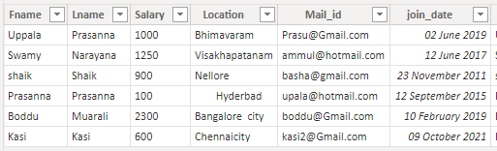

- COMBINEVALUES: By Using this we can combine two or more columns into a single column with the help of specified “Delimiter”.

Syntax: COMBINEVALUES(<delimiter>, <expression>, <expression>[, <expression>]…)

Note: In This we can combine n Number of columns (maximum up to 35-40 columns).
Possible for different datatype columns also combined.
Delimiter is nothing but special characters.

Dax Function: Combinevalues=COMBINEVALUES("_",Test_function[Fname],Test_function[Lname],Test_function[Salary])
Output:
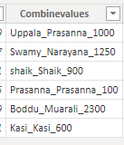

2)CONCATENATE: By Using this we can combine only two columns into a single column.
Syntax: CONCATENATE(<text1>, <text2>)
Dax Function: Cocatenate=CONCATENATE(Test_function[Fname],Test_function[Lname])
Output: 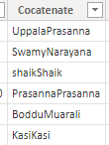
3)CONCATENATEX: By using this, for the selected particular column all values are converted as a single row with the help of specified Delimiter.
NOTE: And also, the result from evaluated for each row in the table.
Syntax: CONCATENATEX(<table>, <expression>[, <delimiter> [, <orderBy_expression> [, <order>]]...])
Dax Function: Concatenatex = CONCATENATEX(Test_function,Test_function[Salary],"-")
Output:
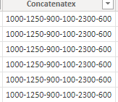

4)EXACT: By using this to compare the two column values, if it matches then it returns True otherwise false.
Syntax: EXACT(<text1>,<text2>)
Dax Function: Exact=EXACT(Test_function[Fname],Test_function[Lname])
Output:
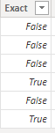

5)FIND: By using this to find the position of the character and it will return as a Number.
Syntax: FIND(<find_text>, <within_text>[, [<start_num>][, <NotFoundValue>]])
NOTE: Its Case-sensitive.
NotFoundValue “means if there is no find text within the text then it returns as Error, so in this place of Notfoundvalue mention any number”.
Dax Function: Find = FIND("@gmail",Test_function[Mail_id],1,0)
Output:
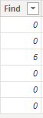
6)SEARCH: By using this to find the position of the character.
Syntax: SEARCH(<find_text>, <within_text>[, [<start_num>][, <NotFoundValue>]])
NOTE: It’s Not Case-sensitive.
“NotFoundValue “means if there is no find text within the text then it returns as Error, so in this place mention any number”.
Dax Function: Search = SEARCH("@gmail",Test_function[Mail_id],1,0)
Output:
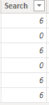

7)FIXED: By using this to convert numeric value into decimal value for the specified decimal values.
Syntax: FIXED(<number>, <decimals>, <no_commas>)
NOTE:<decimal> mentioning how many decimal places, <no-commas>means mention 1 or 0. if mention “1” do not display commas, if “0” mention display commas.
Dax Function: Fixed = FIXED(Test_function[Salary],2,1)
Output:
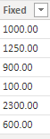

8)FORMAT: By using this we can display the particular selected column with different formats and also, we can display the different outputs.
Syntax: FORMAT(<value>, <format_string>[, <locale_name>])
Dax Function: 1) Format=FORMAT(Test_function[join_date],"yyyy-mm-dd")
- Format_year=FORMAT(Test_function[join_date],"yyyy")
- Format_month = FORMAT(Test_function[join_date],"mmmm")
- Format_dateformate = FORMAT(Text_function[Date],"yyyy/mm/dd")
- Foramt_day name= FORMAT(Text_function[Date],"dddd")
- Format_day = FORMAT(Text_function[Date],"d")
- Foramt_monthnum = FORMAT(Text_function[Date],"mm")
- Foramt_based_numeric = FORMAT(Text_function[Search_casesenstive],"#0.00")
- Foramt_now_ist = COMBINEVALUES(" ",FORMAT(NOW(),"HH:mm am/pm dddd,dd mmmm yyyy"),"(IST)")

NOTE: In this We can write so many Dax function with different formats.
Output:
1) 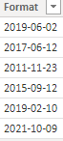 2) 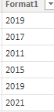 3) 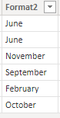

9) VALUE: By using this convert text into decimal values.
Syntax: VALUE(<text>)
Dax Function: Value=VALUE(Test_function[Incre])
Output:
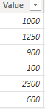

10)LEFT: By using this to display the specified number of characters from the start position of the string.
Syntax: LEFT(<text>, <num_chars>)
Dax Function: Left = LEFT(Test_function[Mail_id],5)
Output:
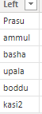

11)RIGHT: By using this to display the specified number of characters from the last position of the string.
Syntax: RIGHT(<text>, <num_chars>)
Dax Function: Right = RIGHT(Test_function[Mail_id],3)
Output:
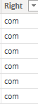

12)LEN: By using this to display the number of characters in a string.
Syntax: LEN(<text>)
Dax Function: Len = LEN(Test_function[Fname])
Output:
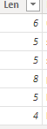

13)LOWER: By using this to convert the all the characters in a string as a Lowercase.
Syntax: LOWER(<text>)
Dax Function: Lower = LOWER(Test_function[Fname])
Output:
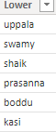

14) UPPER: By using this to convert the all the characters in a string as a Uppercase.
Syntax: UPPER(<text>)
Dax Function: Upper = UPPER(Test_function[Lname])
Output:
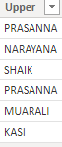
15)MID: Returns a string of characters from the middle of a text string.
Syntax: MID(<text>, <start_num>, <num_chars>)
Dax Function: Mid = MID(Test_function[Mail_id],6,6)
Output:
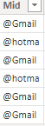

16)REPT: By using this to repeat the cell values for the specified times in a cell.
Syntax: REPT(<text>, <num_times>)
Dax Function: Rept=REPT(Test_function[Salary],2)
Output:
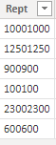

17)REPLACE: By using this to replace the part of the string with another new string.
Syntax: REPLACE(<old_text>, <start_num>, <num_chars>, <new_text>)
Dax Function: Replace = REPLACE(Test_function[Mail_id],6,1,"_")

Output:
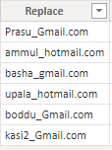

18)SUBSTITUTE: By using this to replace the existing string with a new string.
Syntax: SUBSTITUTE(<text>, <old_text>, <new_text>, <instance_num>)
Dax Function: Substitute=SUBSTITUTE(Test_function[Mail_id],"com","in")
Output:
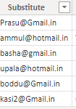

19)TRIM: By using this to remove the blank spaces or white spaces before or after the text string.
Syntax: TRIM(<text>)
NOTE: Trim Function does not remove the spaces between the words.
Dax Function: Trim=TRIM(Test_function[Location])
Output:
